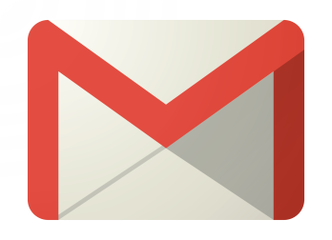
How to Create a Gmail Account

- Go to www.gmail.com
- Click on Create an Account
- You will be redirected to a Create a new Google Account window.
- Your username will become part of your email address so use something that is simple and easy to remember.
- Type in the password you want to use. The password should be easy for you to remember without being obvious enough that someone else may guess it.
- Your password should include a series of letters, numbers and symbols
- Fill in information regarding your birthday and gender
- Google will ask you for a mobile phone number in order to send you a text if you have forgotten your password. The mobile phone number is not necessary to create a Google account.
- If you have another email account you can include it on the form. Google will use that information to contact you if there is a problem with your Gmail account.
- Type in the verification text.
- Select your location.
- Accept the Terms of Service and Private Policy
- You will have the option to review the About Personalization and participate in Google +.
- Click Next Step to continue
- The Google Welcome Page will appear
- Congratulations! You have successfully created a Gmail account! Now you can set up email alerts from job search sites like Monster.com and Indeed.com

